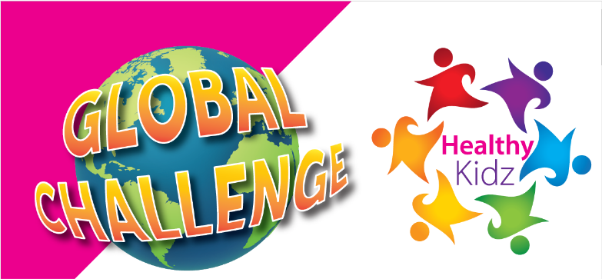

School Kids Global Challenge Launching 30th March 2020
Good Afternoon,
Firstly, we hope you are all keeping safe and well at this time. Our lives have changed and our schools kids are now having to follow new rules.
We are totally committed to finding new and innovative ways to support our schools through these unprecedented times.
So to keep our pupils, families and communities remaining active we are launching The Healthy Kidz Global Challenge
This will allow pupils, families and friends all over the world to join together and compete in a fun way.
***********
** FREE TO JOIN **
Log points for any activity on our newly revamped Healthy Kidz App

* Mini Workouts,
* Game Ideas
* Beat the Coach Challenges.
* Weekly physical activity challenges
* Mindfulness Tips
√ Compete against each other in a safe and positive way.
√ Win awards and certificates and climb the Healthy Kidz leaderboard.

√ Record 7 days streaks on the Healthy Kidz App and be entered into a draw to win some fantastic prizes.
√ Non-sport specific
√ Fun for all of the family to get involved.

Lets keep active
#movementformovement
If previously signed up, please log out and re-register for new details
Please contact Paul@healthy-kidz.com or Gail@healthy-kidz.comif you require any further information regarding our Global Challenge.
As ever, we appreciate your continued support and look forward to continuing to deliver our In School Programmes when it is safe to do so.

