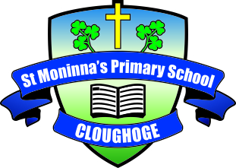

9th April 2020
Dear Parents
We are currently planning work for the weeks after Easter.
Next week you and the children should take a break from school work and attempt to enjoy the Easter holidays as best you can in these circumstances.
New work will be uploaded on Monday 20th April for each year group.
We are currently exploring options for on-going communication between parents, children and teachers.
The Nursery have an email communication system in place which appears to be working well so that will continue unchanged.
Foundation Stage and Key Stage 1 (Primary 1 to Primary 4) teachers will put their email details on the Home Learning Class Pages on school website. This means parents can communicate directly with class teacher and any queries will be responded to by email.
Classes already operating Class Dojo will continue to do so. This may be extended to other classes.
Key Stage 2 (Primary 5,6 & 7) will use Google Classrooms. This is available through the schools C2K system so all the pupils will be able to access it with their C2K user name/password. Further details for this will be on school website after Easter.
If your child is supported by Mrs Joanne O Hagan, she is happy for you to get in touch with her directly. Mrs O Hagan can give you advice on tailoring work to meet your child’s particular needs. Her email address is johagan529@c2kni.net.
Nursery and Primary 1 offer of place letters will be issued as normal on 28th April.
We have no further information on GL Transfer arrangements for November. Our expectation, at this stage, is that they will happen as planned.
I would like to wish you and your family a safe, healthy and happy Easter.
Yours sincerely,

Isobel Temple
Principal

