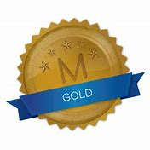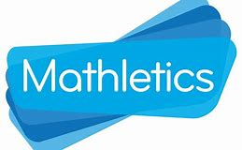
Weekly Class Winners

Primary 1  Mrs Crilly | Rory  Doherty
Primary 1  Mrs Murphy/Miss Hamill | Mikolaj  Kasprzykowski
Primary 2  Mrs McKevitt | Lorcan  Teggart
Primary 2  Mrs McEvoy/Miss Hamill | Neida  Klimasauskaite
Primary 3  Mr Murtagh | Danielius  Vereckis
Primary 3  Mrs McNally | Zara  Markey
Primary 4  Mrs McGivern | Senan  McDonnell
Primary 4  Mrs Quinn | Aoibheann  O’Kane
Primary 5  Mrs Gregory | Alex  Borobia
Primary 5  Mrs Fearon/Mr McCann | Orlaigh  Mackin
Primary 6  Mrs Hicks | Jessica  McManus
Primary 6  Mrs Walsh/Mrs Keane | Finn  McDonald
Primary 7  Mr Byrne | Julia  McGivern
Primary 7  Mrs McKevitt | Grace  Mackin

