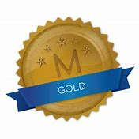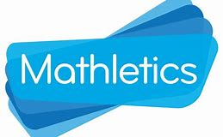
Weekly Class Winners

Primary 1  Mrs Crilly | Erik  Karmilcovas
Primary 1  Mrs Murphy/Miss Hamill | Mikolaj  Kasprzykowski
Primary 2  Mrs McKevitt | Lorcan  Teggart
Primary 2  Mrs McEvoy/Miss Hamill | Neida  Klimasauskaite
Primary 3  Mr Murtagh | Lily  Gunne Curtis
Primary 3  Mrs McNally | Shea  Ward
Primary 4  Mrs McGivern | Senan  McDonnell
Primary 4  Mrs Quinn | Dylan  Caffrey
Primary 5  Mrs Gregory | Jack  McManus
Primary 5  Mrs Fearon/Mr McCann | Eve  Convery
Primary 6  Mrs Hicks | Lexie  McCauley
Primary 6  Mrs Walsh/Mrs Keane | Anna  McKeown
Primary 7  Mr Byrne | Corey  McVeigh
Primary 7  Mrs McKevitt | Mia  McShane

