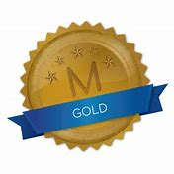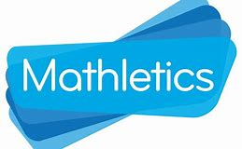
Weekly Class Winners

Primary 1  Mrs Crilly | Fabian  Tutaj
Primary 1  Mrs Murphy/Miss Hamill | Aiobheann  Payne
Primary 2  Mrs McKevitt | Lorcan  Teggart
Primary 2  Mrs McEvoy/Miss Hamill | Keegan  Haffey
Primary 3  Mr Murtagh | Jakub  Gajewski
Primary 3  Mrs McNally | Ava  McKeefry
Primary 4  Mrs McGivern | Senan  McDonnell
Primary 4  Mrs Quinn | Dylan  Caffrey
Primary 5  Mrs Gregory | Kealan  McDonnell
Primary 5  Mrs Fearon/Mr McCann | Tom  Stanfield
Primary 6  Mrs Hicks | Lena  Tutaj
Primary 6  Mrs Walsh/Mrs Keane | Michael  Collins
Primary 7  Mr Byrne | Corey  McVeigh
Primary 7  Mrs McKevitt | James  Mayne

