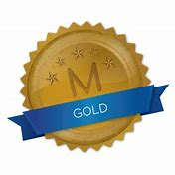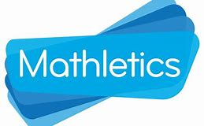
Weekly Class Winners

Primary 1  Mrs Crilly | Emilia  Kornatowska
Primary 1  Mrs Murphy/Miss Hamill | Paidi  McKeefry
Primary 2  Mrs McKevitt | Lorcan  Teggart
Primary 2  Mrs McEvoy/Miss Hamill | Rian  McEvoy
Primary 3  Mr Murtagh | Jakub  Gajewski
Primary 3  Mrs McNally | Ava  McKeefry
Primary 4  Mrs McGivern | Oliver  Cottrell
Primary 4  Mrs Quinn | Nojus  Belskus
Primary 5  Mrs Gregory | Eabha  Donaghy
Primary 5  Mrs Fearon/Mr McCann | Nuadu  Ó Gribín
Primary 6  Mrs Hicks | Filip  Szarzynski
Primary 6  Mrs Walsh/Mrs Keane | Finn  McDonald
Primary 7  Mr Byrne | Oskar  Grajnert
Primary 7  Mrs McKevitt | Richie  Gilligan

