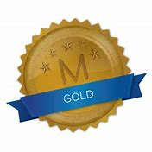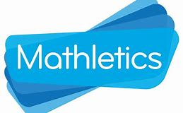
Weekly Class Winners

Primary 1  Mrs Crilly | Erik  Karmilcovas
Primary 1  Mrs Murphy/Miss Hamill | Paidi  McKeefry
Primary 2  Mrs McKevitt | Lorcan  Greene
Primary 2  Mrs McEvoy/Miss Hamill | Neida  Klimasauskaite
Primary 3  Mr Murtagh | Danielius  Vereckis
Primary 3  Mrs McNally | Ava  McKeefry
Primary 4  Mrs McGivern | Alfredo  Fusco
Primary 4  Mrs Quinn | Aoibheann  O’Kane
Primary 5  Mrs Gregory | Jack  McManus
Primary 5  Mrs Fearon/Mr McCann | Nuadu  Ó Gribín
Primary 6  Mrs Hicks | Jessica  McManus
Primary 6  Mrs Walsh/Mrs Keane | Adam  Burke
Primary 7  Mr Byrne | Aebha  Phillips
Primary 7  Mrs McKevitt | Denis  Lenkutis

