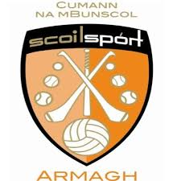

Armagh Cumann na mBunscol have recently launched the 'Cumann na mBunscol Fun in the Summer' Competition. This could be a short movie or photo collage or some other format of your choice showing Gaelic Games Promotion. As Allianz have been a long standing sponsor of Cumann na mBunscol, the idea is that you try and promote Allianz within your submission. You could include the picture below in your entry.

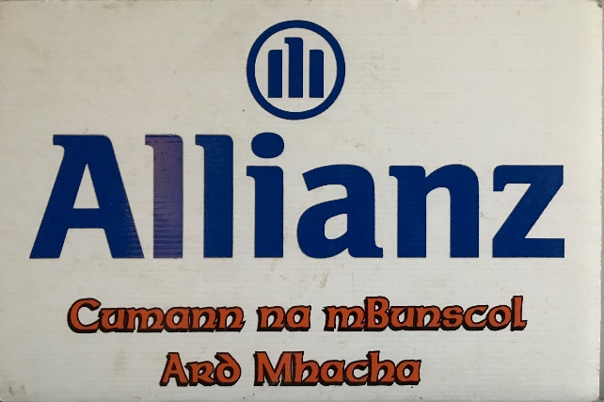
You must then send your submission to
Mrs Hicks at chicks766@c2ken.net

All entries will then be uploaded to the Armagh Cumann na mBunscol twitter page @armaghcnamb

Closing date will be Friday 26th June 2020.

The top three schools who receive the highest number of likes on the Cumann na mBunscol Twitter Page (Not the school's own twitter page) will receive a cheque for £100.

Check out Mrs Hicks’ entry on
the next page!

Remember to visit the GAA website for their weekly challenges.
Issue 7 of the #GAAPrimary Challenges is now published
You will find all the information on the links below:

Issue 7 Junior classes - https://learning.gaa.ie/sites/default/files/7%20Senior%20doc.pdf

Issue 7 Senior classes - https://learning.gaa.ie/sites/default/files/7%20Junior%20doc.pdf

Watch the video of Cumann na mBunscol Ard Mhacha Chairman, Gary Farrell, on the link below.

https://www.youtube.com/watch?v=g718xffNaps

'Cumann na mBunscol Fun in the Summer'

Brother/Sister

Cousins
Grandparents
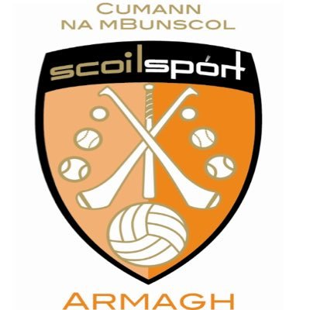

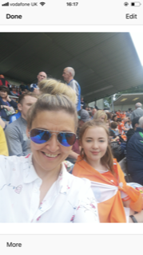

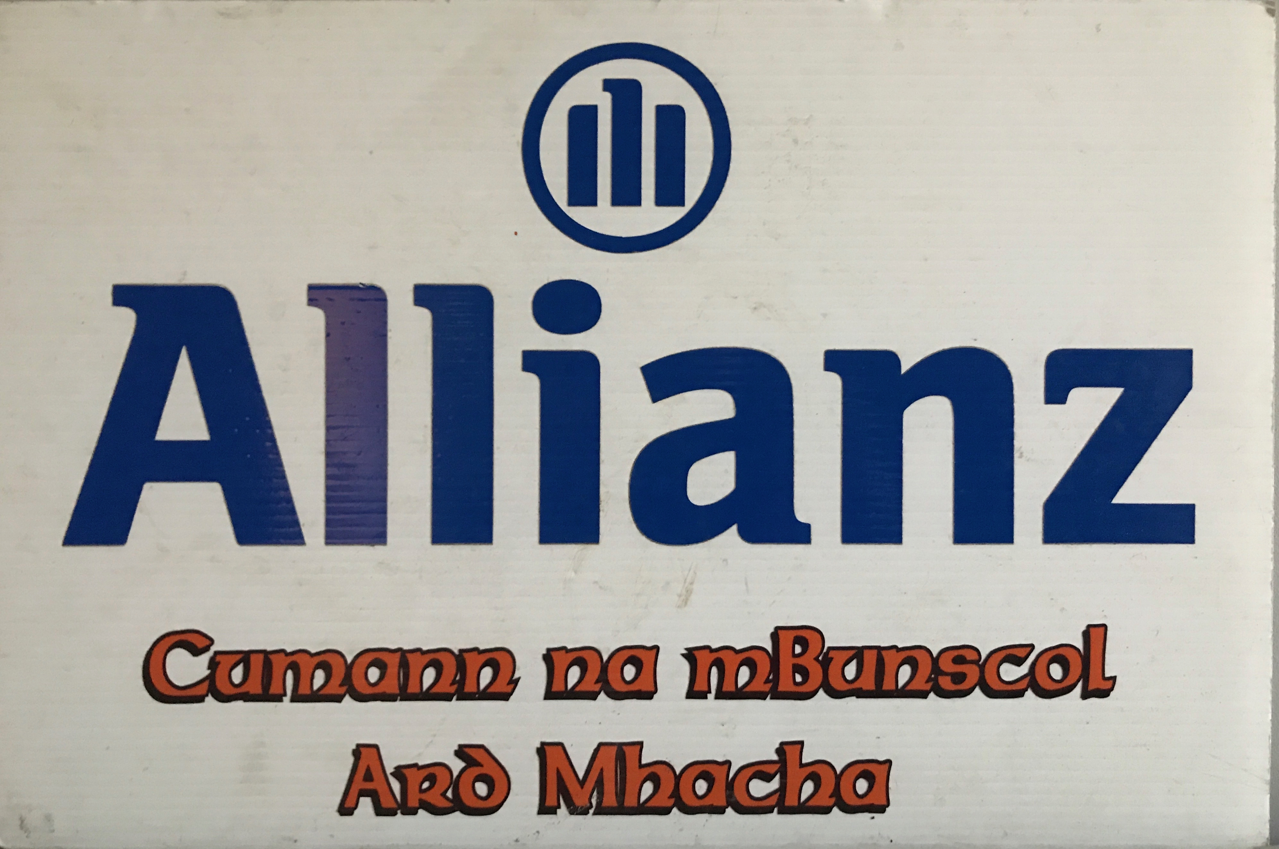
The GAA:
It’s all about family!

