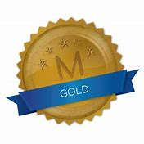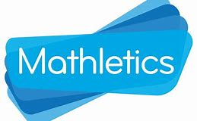
Weekly Class Winners

Primary 1  Mrs Crilly | Rory  Doherty
Primary 1  Mrs Murphy/Miss Hamill | Mikolaj  Kasprzykowski
Primary 2  Mrs McKevitt | Lorcan  Teggart
Primary 2  Mrs McEvoy/Miss Hamill | Rian  McAvoy
Primary 3  Mr Murtagh | Jack  Curran
Primary 3  Mrs McNally | Ava  McKeefry
Primary 4  Mrs McGivern | Alfredo  Fusco
Primary 4  Mrs Quinn | Oliver  Cottrell
Primary 5  Mrs Gregory | Donnchadh  Coleman
Primary 5  Mrs Fearon/Mr McCann | Nuadu  Ó Gribín
Primary 6  Mrs Hicks | Filip  Szarzynski
Primary 6  Mrs Walsh/Mrs Keane | Adam  Burke
Primary 7  Mr Byrne | Oskar  Grajnert
Primary 7  Mrs McKevitt | James  Mayne

