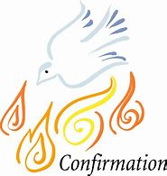

Confirmation will take place in the Sacred Heart Church, Cloughoge on Saturday 5th September 2020.

Each class will have their own ceremony at separate times to allow for appropriate distancing in the church.

Mrs. Mc Kevitt’s P7 class will have their ceremony at 11am and Mr. Byrne’s class will have theirs at 1pm. There will be one seat allocated per family and children do not need to wear their school uniform. Further information will be sent out when school returns on 24th August.

