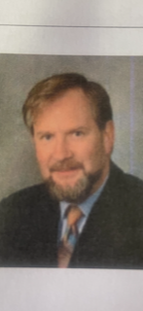

**Former Principal Robert Keogh passed away in Australia this week surrounded by his loving family. Robert served as Principal of Cloughoge Primary School from 2000 to 2006. Prior to this he was Principal of Armagh CBS. During his time in Cloughoge he led the school into a new century and a new era. He was a highly cultured man with a great love of the Irish language and music; he was also an eloquent orator. Robert’s role as Principal focused on a child centred approach to teaching and learning. The children being at the heart of all decision making. He worked tirelessly for the school community and is fondly remembered by staff and former pupils.**

**May he Rest in Peace.**