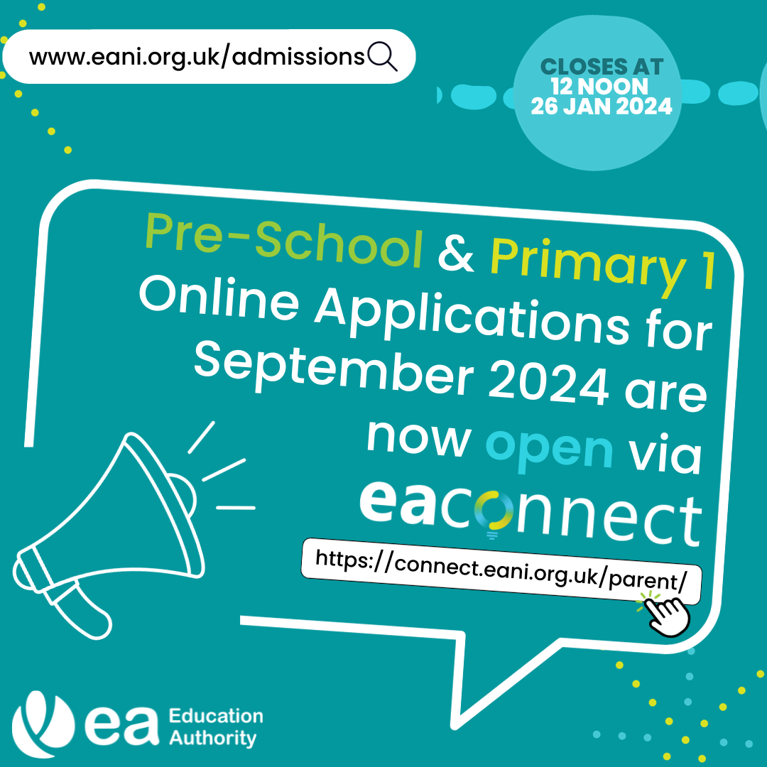
Online applications for a Pre-School or Primary 1 place for September 2024 are now open via EA Connect.
Applications close at 12 noon on Friday 26 January 2024, and it is important to note that applications are not considered on a first come, first served basis.
EA recommends that you list at least four pre-schools or primary schools in the order of your preference. Make sure you read carefully through the published admissions criteria for the pre-school settings and schools you are considering before submitting your application.
Visit https://connect.eani.org.uk/parent/ to apply and see EA’s website for more information on the admissions process: www.eani.org.uk/admissions

If you are currently or have recently applied for your child’s Primary 1 place, you can use EA’s eligibility tracker to check if your child is eligible for transport to the primary schools you are considering. Visit: https://www.eani.org.uk/financial-help/home-to-school-transport/check-transport-eligibility
For more information on the admissions process and to begin your application, visit: www.eani.org.uk/admissions #EAadmissions

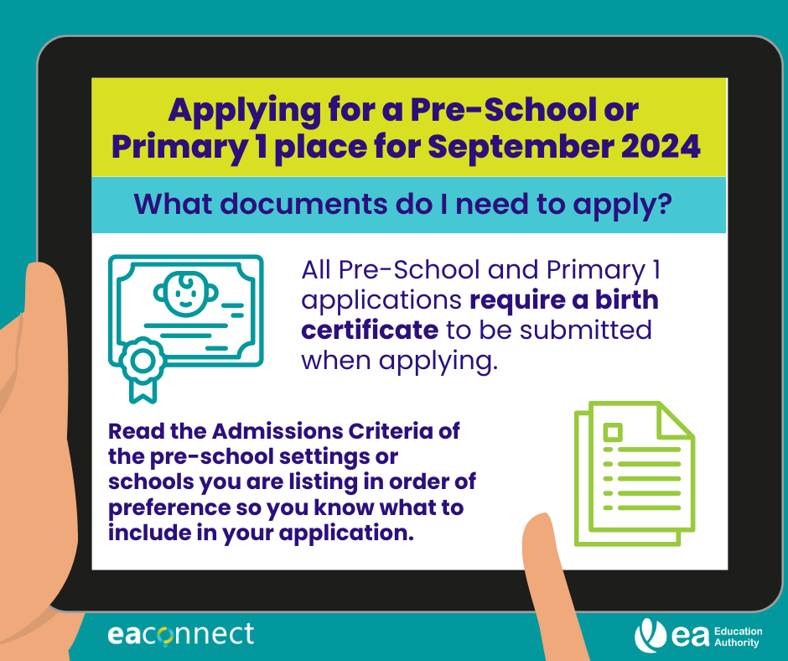

If you have recently submitted your child’s Pre-School or Primary 1 application, and have yet to supply your supporting documentation, the deadline is 31 January 2024 at 4pm.
Visit https://connect.eani.org.uk/parent/ to upload your documentation.
For further information on admissions, please visit: www.eani.org.uk/admissions
#EAadmissions

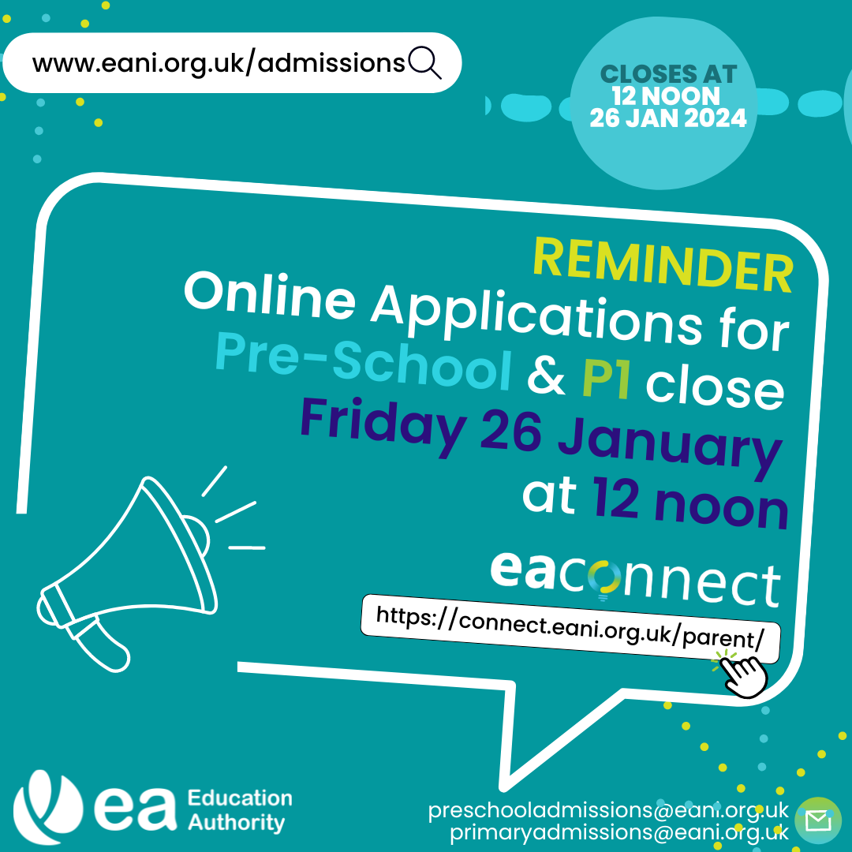
Pre-school and Primary 1 online applications close 26th January at 12 noon! Any applications received after this date will be treated as late.
If you have yet to submit an application, please visit: https://connect.eani.org.uk/parent/
Deadline for submitting supporting documentation is 31 January at 4pm.
For further information on admissions, please visit: www.eani.org.uk/admissions
#EAadmissions

